STURTON AND STOW NEIGHBOURHOOD PLAN GROUP

Notes of the meeting to arrange Neighbourhood Profile fulfilment held at
7pm Thursday 26th March 2019 in the Sturton Old Schoolroom.

Present: Mel Banham (Chair),Gordon Bruce, Carol Gilbert,
Chris Grinham-Green, Carl Hawke, Ben Irving, Paula Justham, Mike Metcalfe, Dennis M.Taylor, Rosalind Watson,

Apologies: Pam Duncan, Lorraine White, Norman Read,
Clive Thompson

1. Define and finalise number of neighbourhood in Plan area

Five aspects of character and areas were agreed on as follows:
- Sturton by Stow built area pre WW2
- Sturton by Stow built area post WW2
- Stow, built area, both pre WW2 and post WW2
- Coates, Normanby and Stow Park (to A1500 Marton Road) as farmed rural area
- Stow Park (south of A 1500 Marton Road), Bransby and Thorpe Lane as farmed rural area with major visitor facility (Bransby Horses).

It was agreed that each of the five merited a character overview and walkabout event as this would provide a comprehensive character profile of the Plan area.

It was agreed that areas 4 and 5 would be part drive about with walks at particular points of reference. Approximate event areas shown on map below:

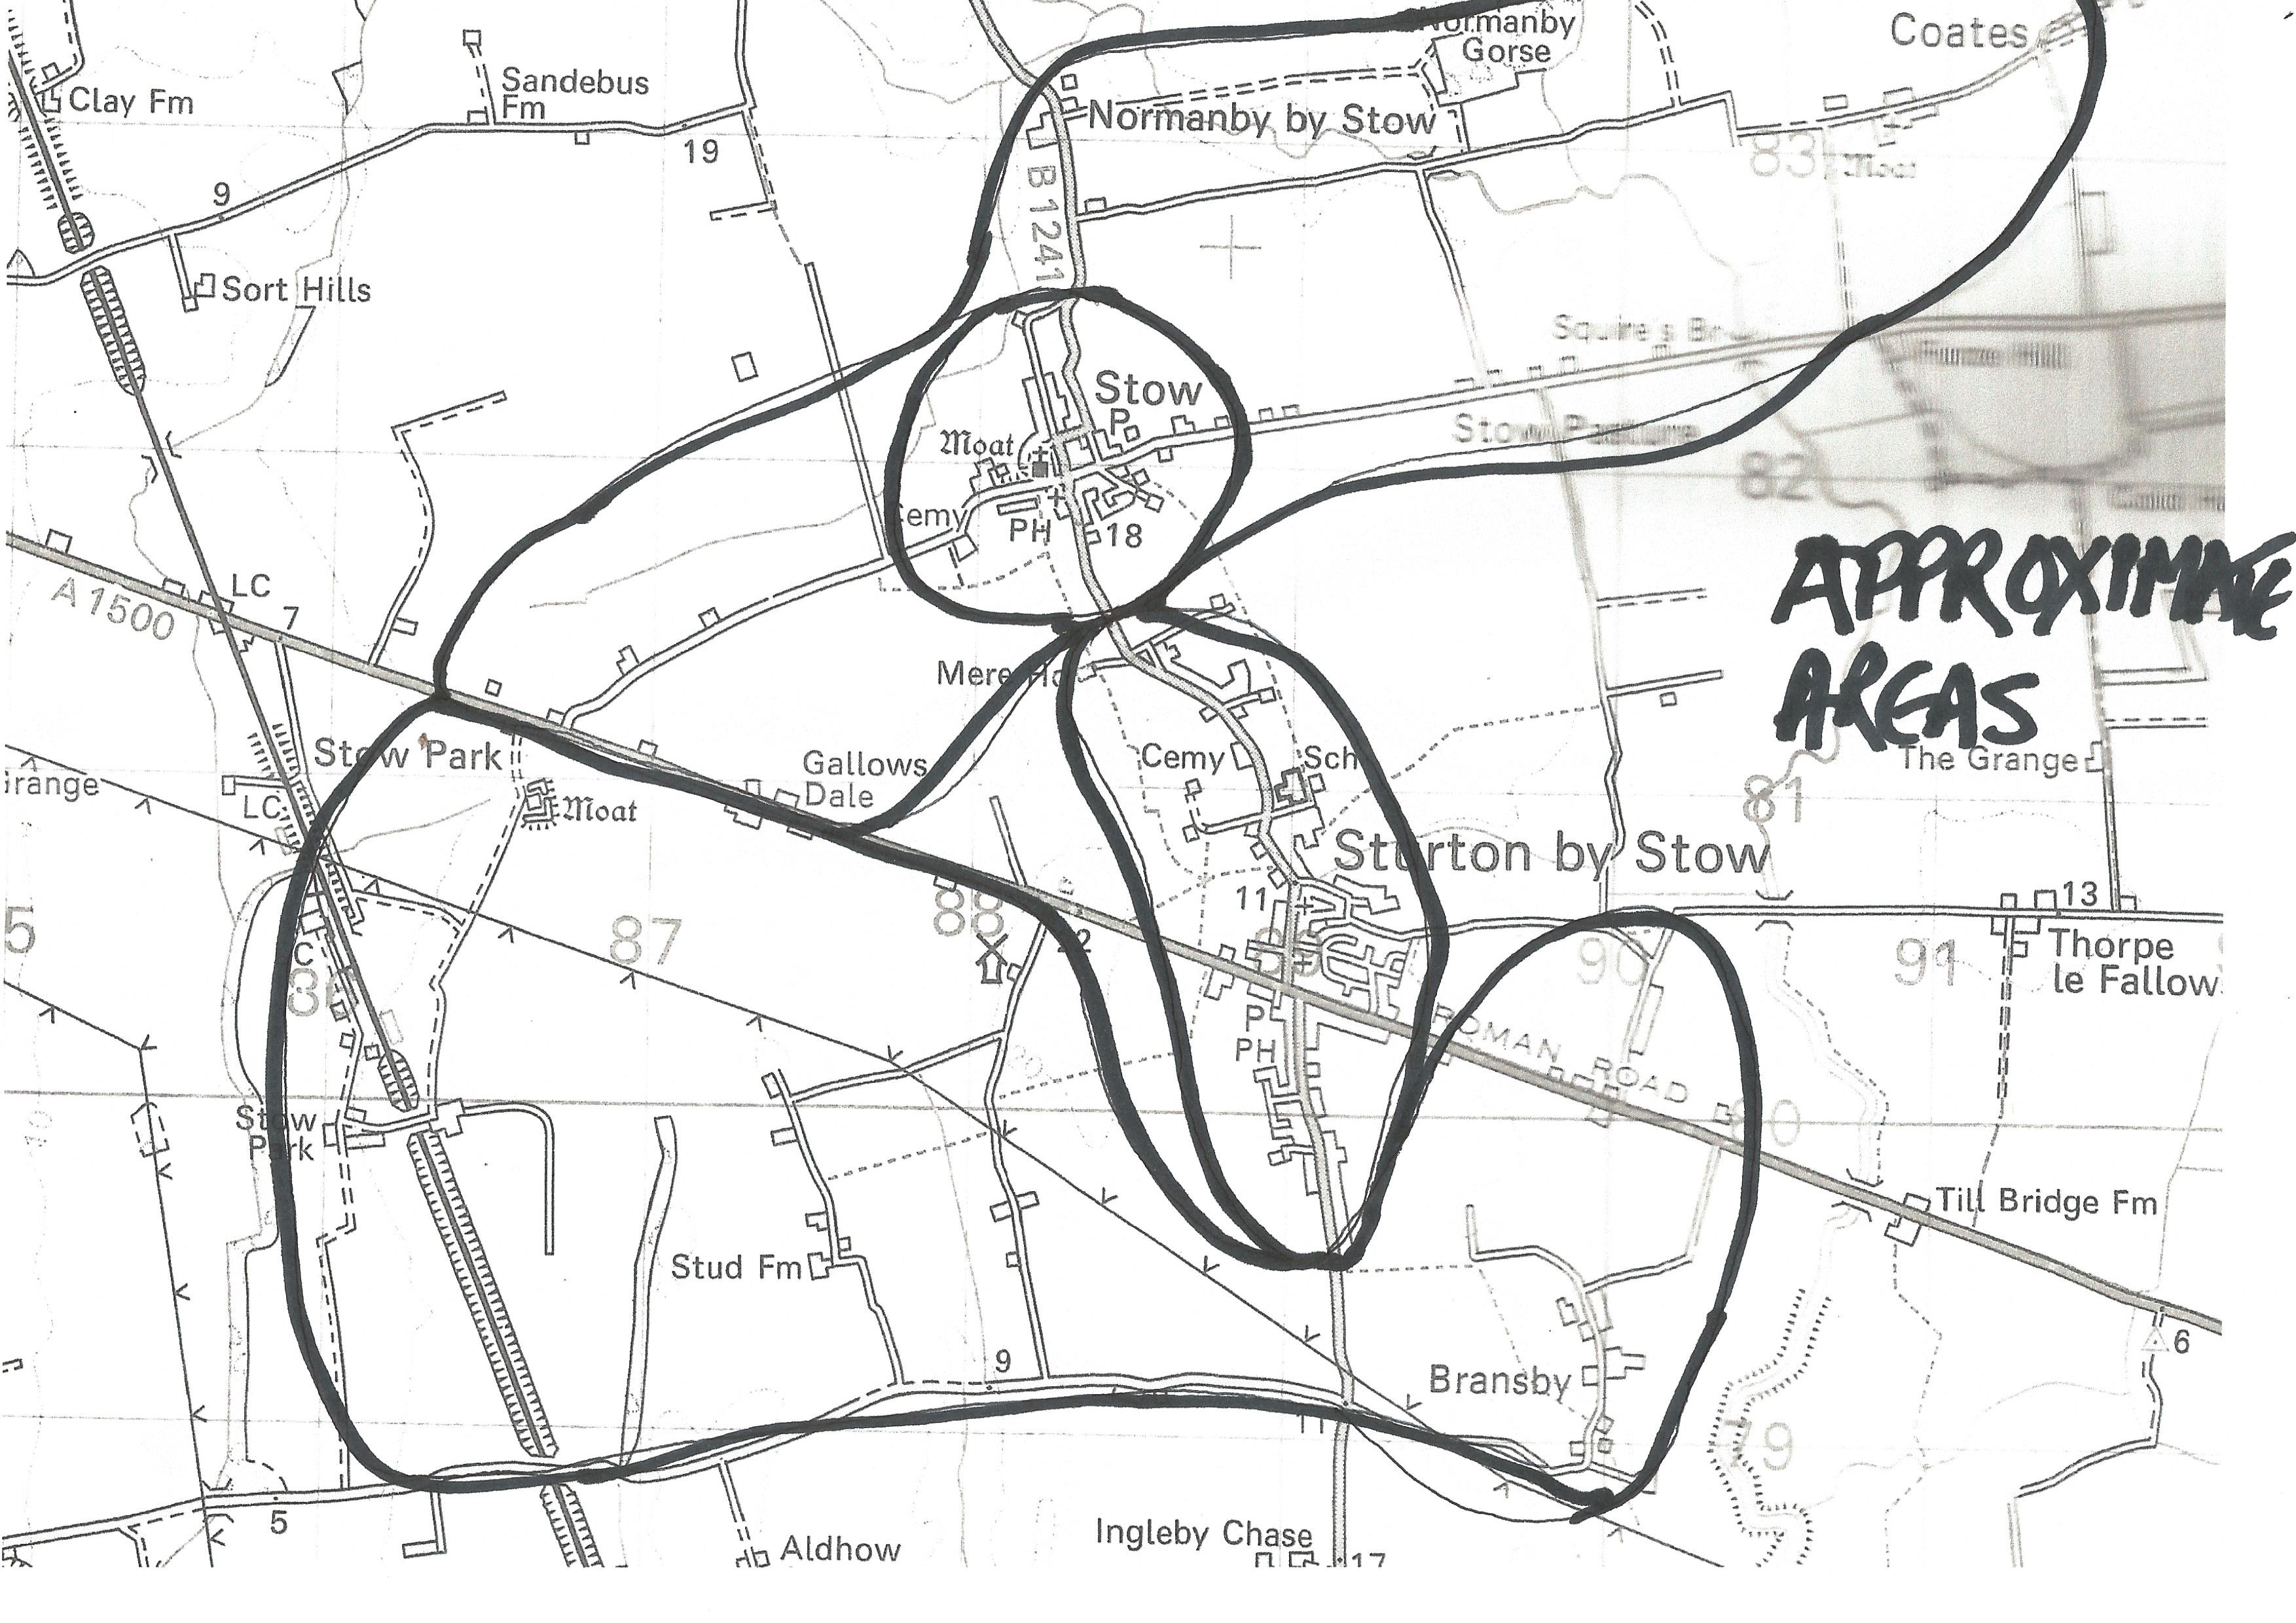

2. Event co-ordination

It was agreed that it would be best if two people co-ordinated each event, preferably with a nominated photographer. This would enable one person to handle character overview element and one to lead discussion on walkabout.

It was also agreed that meeting venues be identified for character overview and return from walkabout for refreshment, etc.

It was agreed that it would be requested that refreshment costs be re-imbursed by Sturton by Stow Parish Council, on provision of receipts, as this evidenced expenditure could be reclaimed as part of the Neighbourhood Plan grant.

3. Potential dates

The dates agreed at a previous meeting were Saturday May 4th, Sunday May 5th and Saturday May 11th. The following table summarises dates, timings, venues and co-ordinators (agreed and suggested).

Event | Date | Time | Co-ordinators | Venue | Photographer
Sturton by Stow pre 1945 | Sunday 5th May | 1pm | Carl Hawke  Mike Metcalfe | Old school Room | Carol Gilbert?
Sturton by Stow after 1945 | Sunday 5th May | 1pm | Ben Irving  Ros Watson | Sturton VH upstairs | TBC
Stow both before and after 1945 | TBC | TBC | Norman Read?  A N Other | TBC | Doug Garner?
Coates, etc | TBC | TBC | Pam Duncan?  A N Other | TBC | TBC
Bransby, etc | Saturday 4th May | 10am | Chris Grinham-Greene  Mel Banham | Bransby Horses | TBC

ACTION FROM 2&3:

MB to book upstairs meeting room at VH for 5/5/19 from 1-4pm.
MB to book meeting facility at Bransby Horses for 4/5/19 from 10am.
MB to book OSR for 5/5/19 from 1-4pm.
PD to confirm availability/date and time, etc
NR to confirm availability/date and time, etc
Co-ordinators to liaise accordingly, recruit photographer if possible, etc.

4. Publicity

It was decided that participants should pre-book their presence so that co-ordinators could manage numbers, materials, refreshments, etc. This would be done by email, telephone, word of mouth.

It was also decided that, given time constraints, publicity should comprise mainly the following:
- Email/phone to an existing list of people who have previously expressed interest in taking part
- Poster with booking arrangement information
- Social media
- Plan website
- Booking sheets at Sturton by Stow village market (Saturday April 6th) and any other opportunities.

ACTION:

MB to brief Trudi Hayes so that she can draft a poster
GB to arrange for phone to be usable
All to use social media once full information is confirmed
MB to arrange booking sheets for market

5. Review of exercise and collation of information

It was understood and agreed that Open Plan required all written information transcribed to be received electronically and all photographs to be clearly labelled (place, direction, time, etc).

It was agreed that the review, progress reports were best undertaken at the following existing NPG meeting. Currently arranged for Thursday May 9th if moved to Thursday 16th it would enable this.

ACTION:

PD to rearrange and notify change of May meeting date

